**THE SIMPLIFIED TRIANGLE METHOD**

**A SIMPLE METHOD FOR ESTIMATING AREAL EVAPOTRANSPIRATION AND SURFACE SOIL MOISTURE FROM OPTICAL AND THERMAL INFRARED SATELLITE MEASUREMENTS**

**Toby N. Carlson**

**Professor Emeritus**

**Dept. of Meteorology and Atmospheric Science**

**Penn State University**

**University Park, PA 16802**

**Email: tnc@psu.edu**

1. **INTRODUCTION AND INPUT PARAMETERS**

The simplified triangle method allows one to make estimates of surface evapotranspiration fraction (EF) and surface soil moisture availability (Mo) over an area using only a few simple calculations in conjunction with satellite measurements for images made at optical wavelengths and in the thermal infrared. **No land surface model is needed in order to implement this method.**

The basic input are two image fields derived from satellite (or aircraft) measurements, one of surface radiometric temperature (Tir) and the other the normalized difference vegetation index (NDVI), The latter is derived from a pair of radiances measured at two wavelengths in the solar spectrum, one in the visible and one in the near infrared. NDVI (defined below; see also Gillies et al., 1997; Owen et al., 1998) is used to calculate the fractional vegetation cover (Fr). Defining NDVI

NDVI= (a2-a1)/(a1+a2) (1)

where a1 and a2 are the reflectance values measured, respectively, in the near infrared (e.g. 0.7 microns, channel 4 of Landsat) and visible (e.g. 0.6 microns, channel 3 of Landsat). Calculation of the fractional vegetation cover requires some image analysis, described below. Moisture availability Mo is a surface dryness parameter, loosely defined as the ratio of soil water content to that of field capacity. As such, Mo applies only to the top few millimeters of the bare soil surface. Similarly, the bare soil surface radiometric temperature Ts applies to the skin surface of the bare soil. Tir, of course, pertains to a mixture of the bare soil surface and the vegetation canopy temperature Tveg. Most of the following text is based mostly on just a few papers (Gillies et al., 1997; Carlson 2007; Carlson 2013).

1. **IMAGE ANALYSIS**

Images required are those of Tir and optical reflectance. Choice of these images should be based on the following two criteria: (1) reasonably uniform in altitude (not varying by more than about 10%) and (2) not containing a large fraction of standing water or cloud. Although different types of vegetation may be present in the image, highly inhomogeneous vegetation such as a forest aside a field of corn or a body of standing water might introduce some error (including edge effects) in the estimates of moisture availability Mo and the evapotranspiration fraction EF. Here we define EF as the ratio of evapotranspiration ET to net radiation (Rn). Mo is the ratio of evapotranspiration ET to the potential evapotranspiration (ET/ETpot). We define (with some justification) the latter as the ratio of soil moisture to that at field capacity.

Estimate of fractional vegetation cover (discussed below) depends on having some vegetation and bare soil in the image. It seems quite likely that bare soil and vegetation coexist (at least in some pixels) for images taken over a larger enough area. By calculating the fractional vegetation cover for each pixel, vegetation and bare soil thereby separated in each pixel. If the image contains some standing water or cloud, these effects are easily separated by judicial analysis of the reflectances.

Now, consider the two images made over a sufficiently large area, one for Tir and the other for NDVI. Figure 1 shows the thermal image processed in ArcGIS software. In this image I selected the pixels of highest value and lowest value of surface temperature. With the aid of the NDVI image (and some skill with the cursor), I can usually identify some pixels representative of dense vegetation (full vegetation cover) and some of bare soil, the latter appropriate to an open lot or city center. Highest values of surface temperature (red areas), such as those found over a paved area or a dry sandy soil, are likely to represent bare soil pixels with effectively zero surface soil moisture (Fr=0, Mo=0). I define Tir and NDVI for these pixels as Tmax and NDVIo.

Let us assume that some pixels lie over vegetation that is either well watered or at least not wilted. Even in arid environments some healthy plants can be found in clumps big enough to fill a pixel. These pixels correcpond to a full vegetation cover (Fr=1.0). Let us define these temperatures as Tmin and the NDVI as NDVIs (the blue areas in Figure 1). Thus, with the aid of a search over the image with the cursor, one can locate hot and cold pixels which define Tmax, Tmin. Similarly, scanning by eye or automatically with an algorithm, one can fine areas of bare soil ( Fr =0) and full vegetation (Fr= 1), these pixels being the same ones used to define Tmax and Tmin. As stated, the full vegetation and bare soil points are defined, respectively, as NDVIs and NDVIo.

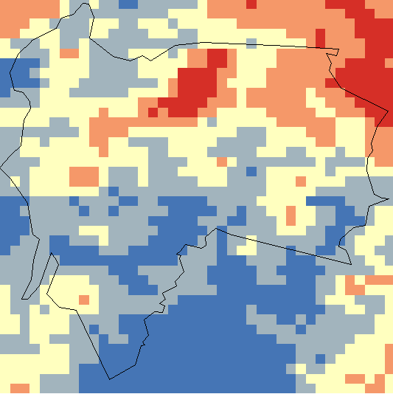

city boundary

Example - lower value of a Tir pixel. Ex: 25,5°C

Example - highest value of a **Tir** pixel . Ex: 42,2°C

Figure 1 Surface radiometric temperature Image. Reds are the hottest and blue the coolest pixels

Having defined these points on the image, the next step is to calculate fractional vegetation cover and Surface Temperature from NDVI. A useful relationship (Gillies et al, 1997) is:

Fr = ((NDVI – NDVIo) / (NDVIs – NDVIo))² (2)

Similarly, we compute a **scaled** infrared surface temperature T* defined as

T* = (Tir – Tmin) / (Tmax – Tmin) (3)

Both the scaled Tir (T*) and the fractional vegetation cover Fr are thus constrained to vary between 0 and 1.0.

As shown by Carlson and Ripley (1997), Fr is highly insensitive to atmospheric attenuation for NDVI, so that no correction for NDVI is needed. Although it has not been conclusively demonstrated, it is quite likely that the scaled temperature T* is less sensitive to atmospheric attenuation than Tir itself. Thus, we assume with some justification that T* requires no correction for atmospheric attentuation. This assumption for Tir rests partly on analogy with NDVI, but its virtue is that neglect of atmospheric attenuation greatly reduces image processing time without engendering serius error.

In Figure 1, maximum and minimum NDVI and Tir for the case represented are NDVIs = 0.9, NDVIo = 0.1, Tmax = 42.7 ° C, Tmin = 25.5 ° C, and. T* varies over 17.2 °C. Given a NDVI of 0.5, Fr computes to be 0.25. In being bounded by two parameters that vary only from 0 to 1.0, the solution for Mo and EF is constrained geometrically by the borders of the triangle, and therefore these solutions become relatively insensitive to external variables such as atmospheric temperature, surface roughness, wind speed, etc.

1. **TRIANGLE DOMAIN**

One can is easily verify that Tir varies greatly with surface wetness over bare soil. Consider the sensation of walking with bare feet in the sun along a beach on a hot day. In walking from dry sand or sidewalk to the wet sand near the water edge, one experiences successive feelings of very hot and cool, perhaps as much as 50°C on hot summer days. Conversely, temperature varies little over vegetation regardless of the state of soil moisture, at least until the plant actively begins to wilt, in which case the vegetation material might be dead. True, temperatures of individual leaves may vary considerably from shade to sun and may increase as the soil dries out in the root zone. Yet, when one considers a vegetation canopy that completely covers an area the size of a pixel (a tens to hundreds of meters on a side), the temperature variation over a pixel or between adjacent and similarly vegetated pixels tends to be minimal, by which we mean Tir varies by an amount within the measurement error of a space-borne radiometer. Moreover, except for special circumstance of transient water stress when Tir might become elevated by a degree or two for a couple hours near mid day (Lynn and Carlson). For aircraft of satellite radiometers, an inherent uncertainty is typically 1 – 2° C. (A useful corollary to this observation is that the canopy temperature for a full vegetation cover is typically about 1 C or so higher than the air temperature Tair just above the canopy. Thus, one can also estimate air temperature from the triangle method.)

The triangle method requires that T* and Fr be plotted for pixels on a two dimensional space as in Figure 2. Because of the sensitivity of Tir to soil moisture over bare soil but not over vegetation, Tir when plotted against Fr over a canopy closely resembles a triangle (or sometimes a trapezoid), although the shape of the triangle tends to degrade as the resolution of the radiometer decreases. A raw image of a triangle, uncorrected for standing water and cloud is shown in Figure 2. This figure is taken from an AVHRR image (1 km resolution). The triangle exhibits considerable scatter due to standing water and cloud near the bottom and especially on the left. These annoyances are filtered by realizing that clouds tend to be cold and highly reflective but yield low values of NDVI while standing water tends to be cold but with very low reflectance and very low values of NDVI.

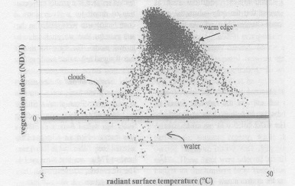

Figure 2. Tir versus NDVI for an AVHRR image (from Arthur-Hartranft et al., 2003)

A striking feature of this kind of pattern is the very sharp edge on the warm side of the triangle, which we label the **warm edge**. It could just as well be called the dry edge as it represents the limit of *surface* soil dryness which we assume also corresponds to a value of Mo=0.   
The base of the triangle, which is sometimes referred to as the **soil line**, corresponding to Fr=0 and an equivalent **cold edge** corresponding to Mo=1.0 are also present in this figure, though a bit blurred by scatter. Finally, the top (**vertex**) of the triangle corresponds to full vegetation cover, Fr=1.0, although the soil, being largely obscured, Mo values are not resolvable. However, in many cases the top of the triangle appears flattened, so that the shape of the pixel envelope more closely resembles a trapezoid rather than a triangle. .

1. **ESSENTIAL FEATURES OF THE TRIANGLE**

Figure 3 shows the essential features of the triangle, specifically the warm and cold edges, the soil line and the triangle’s vertex.

**warm edge:**  The characteristic sharply defined warm side of the triangle can, without great loss of accuracy, be ruled by eye from the lower right-hand vertex (Fr=0 (NDVIo), Tmax) to the upper vertex (Fr=1.0; NDVIs). If the vertex is well-defined, this point is found at NDVIs, Tmin. Some researchers (Tang et al., 2010) divide up slices of Fr between the cold and warm edges into segments of T*, and define the warm edge as the point where the pixel density in these segments decreases to some small number or where, say, 99% of the pixels have been sampled in that slice. Once these points have been determined, a straight-line represents the best fit of the warm edge to these end points at different values of Fr.

This is represented as

T*(warm edge) = 1-bFr (4a)

where b is a constant defining the best line of fit. Recalling that Tir when scaled to T* varies from 0 to 1 (but is equal to or less than 1 along the warm edge), b=1 if the shape of the pixel distribution is a triangle. Thus, for a triangle

T*(warm edge) = 1 – Fr

(4b)

We can see from Figure 4 that the warm edge lines, which are fixed by eye, make reasonable fits to the pixel boundary along the warm edge.

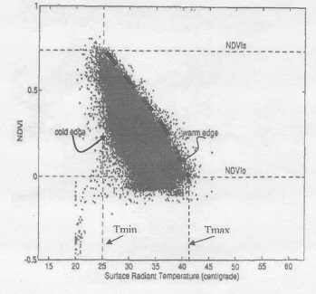

Figure 3. Triangle plotted as NDVI versus Tir created from pixels measured by an aircraft radiometer. (From Gillies et al., 1997)

**cold edge:** Physically, this feature, which represents the limit of wetness, tends to be less well defined than the warm edge. Pixels usually form a less sharp border than for the slanting warm edge, but the border constituting the cold edge tends to be vertically orientated along a straight line drawn between the point (Fr=1.0, Tmin) and (Fr=0; Tmin), as discussed by Jiang and Islam (2001) and Kasim (2015. That this choice of the cold edge is reasonable is attested in Figure 4, which was constructed from a series of images made over fields of soybeans in Brazil. While some triangles tend to tilt toward the left, as can be seen in Figure 3, I believe that the absence of pixels near the lower left part of the triangle in these cases is due to the rarity of truly wet, bare soil surfaces.

**Soil line:**  The bare soil line, (NDVIo) can also be determined by eye or by a statistical test as just mentioned with regard to the warm edge. Figure 4 shows triangles with fairly well-defined bases, although one might contend with the choice of the soil line in Figure 3 and the choices of warm edges in Figure 4.

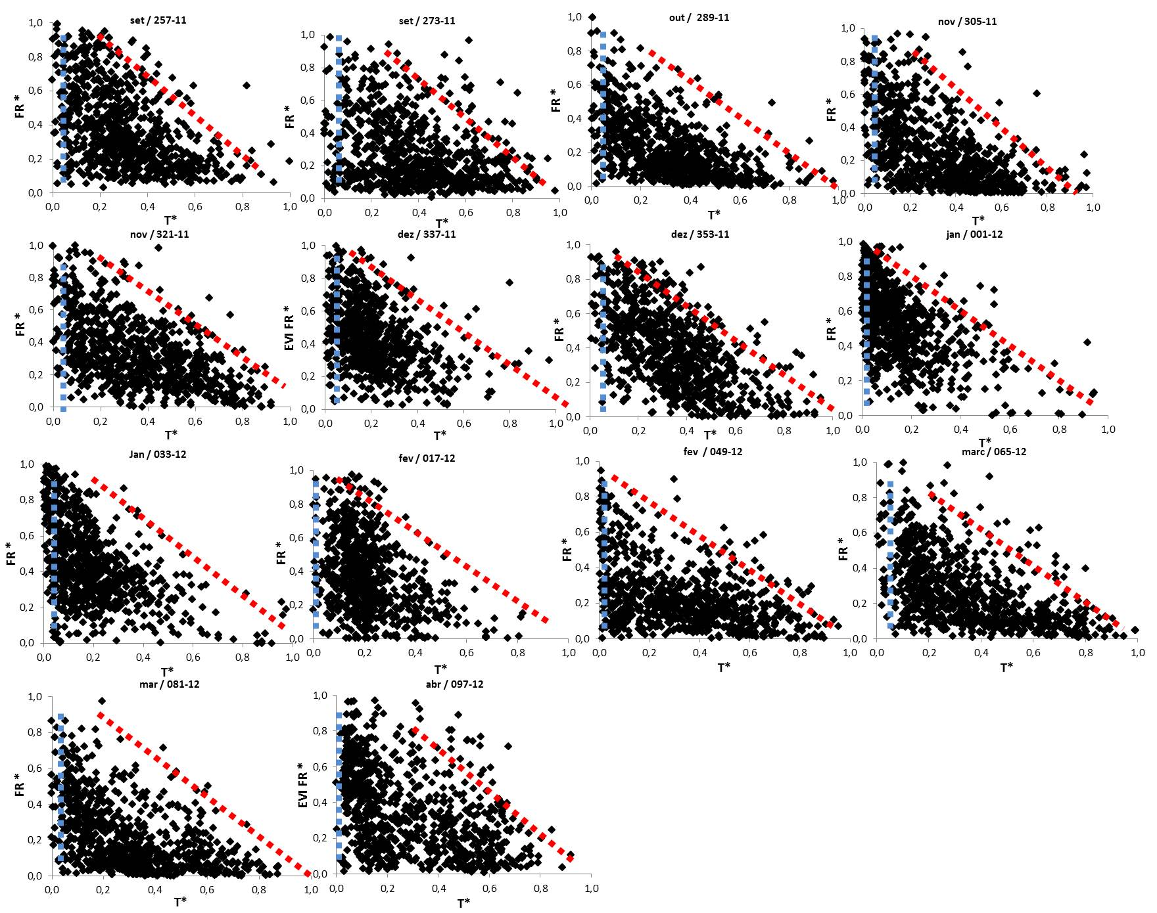

Figure 4. Triangles made from images over soybean fields in Brazil, plotted as in the previous figures, fractional vegetation (here called FR) along the vertical and T* along the horizontal. The sloping red line is the defined warm edge and the vertical blue line is the cold edge. The soil line corresponds to the lower (horizontal) axis. (Silva-Fuzzo and Rocha, 2016)

**Triangle vertex:** Some triangles appear with rounded or flattened tops, more closely resembling trapezoids. This could be due to various factors. Some researchers believe the variation of T* at the point where Fr=1.0 is due to a real variation in leaf temperature due to water stress (Petropoulos et al., 2009). An alternate possibility is that the highest values of NDVI do not represent a truly 100% vegetation cover. It seems unlikely (except in desert-type conditions) that one would be unable to find at least a few pixels that represent a full vegetation cover. My simulations with a SVAT model (described in Petropoulos et al., 2009) suggest that a flattened top can appear in a full vegetation cover not under stress if the leaf area index (LAI) is not very large, say close to 3. Sharp vertices in a triangle may signify that the LAI is very much larger than 3.

1. **SOLUTIONS FOR EF AND Mo USING THE GEOMETRIC VERSION OF THE TRIANGLE METHOD**

**The geometric solution to the triangle method presumes that Mo and EF vary linearly across the pixel domain.** Thus, from Figure 5 we see that Mo is just the ratio of the segments a to d (Petropoulos et al, 2009). Mathematically, this is expressed as

Mo = 1-T* (pixel) )/T* (warm edge) (5)

where T* (pixel ) must always be less than or equal to T* along the warm edge. Thus, if the pixel envelope is a triangle

Mo = 1-T* (pixel)/(1-Fr) (6)

EF = EFsoil (1-Fr) + EFveg *Fr(7)

EF in (7) is weighted by the fractional vegetation cover, where EFsoil = Mo and EFveg = 1.0. Thus, (7) simplifies to the very simple expression

EF = Mo(1-Fr) + Fr (8)

Note that one can substitute (4) in (5) if the triangle has a flat top and the warm edge is determined by a regression line and the factor for best fit (b) is not equal to 1. Some researchers contend that the scatter of points beyond the warm edge represents water stressed vegetation, but this is not provable and can equally be due to sloping terrain.

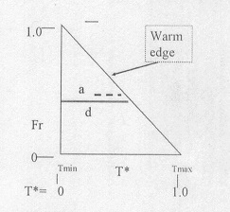

Figure 5. Structure and solution of the triangle using the geometric method. The horizontal segment represents any slice across the triangle at constant Fr, where the letters a and b represent, respectively, a part of the segment and its entire length.

Figure 6 represents a solution to the above equations and illustrates how the isopleths of Mo and EF appear as sloping straight lines on the triangle. As such, Figure 6 constitutes a universal solution for the triangle in which, if pixels in triangles are plotted on the same scale so as to be congruent, they can be overlaid to show time variations of Mo and EF.

If a series of these triangles are created over a period of days, this type of visible representation allows the user to chart the movement of Mo and EF at specific land surface points with time within the triangle. This type of representation allow one to assess the progress of surface drying, thereby adding the dimension of time to the triangle (Owen et al., 1998; Carlson and Sanchez-Azofeifa, 1999; Carlson and Arthur, 2000). An example of this type of time variation of a pixel is illustrated by the arrow in Figure 6, which shows a progressive drying of the surface point as it moves downward and to the right with time.

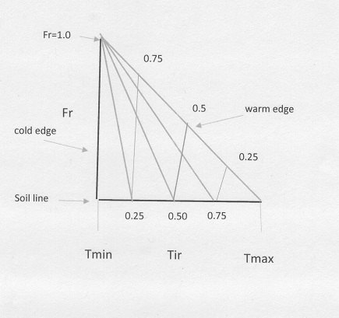

Figure 6. Isopleths of EF (slanting lines toward the right, labelled accordingly) and Mo (slanting lines to the left, labelled accordingly) in the triangle (Fr versus Tir or T*) for the solution of equations (5)-(8). The arrow segment represents a pixel drying with time.

Figure 7 shows isopleths of Mo and EF derived from a full soil /vegetation/ atmosphere/transfer (SVAT) model for a triangular pixel distribution over crops in Costa Rica (Carlson and Sanchez-Asofeifa, 1999). Note that isopleths of Mo are nearly straight lines that slope upward to the left as in Figure 6. Isopleths of EF, however, do tend to resemble so closely those in Figure 6 on the right-hand side but deviate significantly near the lower left side. However, the numerical deviations in EF between the two figures (one determined by the geometric method (figure 6) and the other with the aid of a detailed SVAT model (Figure 7)) is typically no more than about 0.15. Such an uncertainty is certainly within the error of uncertainty in any methodology.

For example, in Figure 5, at Fr= 0.6 and T* of the pixel is 0.1, Mo is equal to 0.75 and EF is equal to 0.9, whereas in Figure 6 Mo is about 0.7 and EF about 0.75. As we see in Figures 6 and 7, as Fr approaches 1 the value of Mo becomes increasingly indeterminate due to the convergence of all Mo isopleths at the upper vertex. Physically, this means that the soil moisture is not resolvable as Fr approaches 1.0, because the soil becomes increasingly obscured by the plants. In trapezoidal plots, however, Mo may be resolvable near the upper vertex.



` Figure 7. Numerical solution for isopleths of Mo (solid lines sloping upward to the left and labeled at 0.1 increments) and EF (solid black lines) versus Fr (percent) and T* (horizontal axis) (From Carlson and Sanchez-Azofeifa, 1999)

1. **SUMMARY**

Solution for Mo and EF using the geometric version of the triangle method is exceedingly simple. Just follow these steps:

1. Prepare images of NDVI and Tir for an area. If the terrain varies by more than 10% in elevation, divide the image into sections at different altitudes.
2. For each image or sub-image, determine the warm and cold edges and the soil line
3. Find the parameters Tmax, Tmin, NDVIo and NDVIs.
4. Calculate Mo and EF using the above equations (6)-(8) for all pixels
5. Optional: create an overlay for Mo and EF on the pixel envelope scaled on a graph from 0 to 1 for T* and Fr. Observe the changes in Mo and EF at individual surface locations with time over a sequence of images.
6. **LIST OF REFERENCES**

Arthur-Hartranft, S. T, T. N. Carlson, and K. Clarke, 2003: Satellite and ground-based microclimate and hydrologic analyses coupled with a regional urban growth model. *Remote Sensing of Environ.*, **86**, 385-400.

Carlson, T. N. and D. A. Ripley, 1997: On the relation relation between NDVI, fractional vegetation cover and leaf area index. *Remote Sensing of Environ.*, **62**, 241-252.

Carlson, T. N. and G. A. Sanchez-Azofeifa, 1999: Satellite remote Sensing of land use changes in and around San Jose’, Costa Rica. *Remote Sensing of Environ.*, **70**, 247-256.

Carlson, T. N. and S. T. Arthur, 2000: The impact of land use-land cover changes due to urbanization on surface microclimate and hydrology: a satellite perspective. *Global and Planetary Change*, **25**, 40-65.

Carlson, T. N., 2013: Triangle models and misconceptions. *Int. J. of Remote Sensing Applications,* 3, 155-158.

Carlson, T. N., 2007. An overview of the triangle method for estimating surface evapotranspiration and soil moisture from satellite imagery. *Sensors,* **7**, 1612-1629.

Gillies, R. R., T. N. Carlson, J. Cui, W. P. Kustas, and K. S. Humes, 1997: A verification of the ‘triangle’ method for obtaining surface soil water content and energy fluxes from remote measurements of the Normalized Difference Vegetation Index (NDVI) and surface radiant temperature. *Int. J. Remote Sensing*, **18**, 3145-3166.

Goward, S. N., B. L. Markham, D. G. Dye, W. Delaney, and J. Yang, 1991: Normalized difference vegetation index measurements from the advanced very high resolution radiometer*. Remote Sensing of Environ.*, **35**, 257-277.

Jiang, L. and S. Islam, 2001: Estimation of surface evaporation map over southern Great Plains using remote sensing data. *Water Res. Research.*, **37**, 329-340.

Kasim, A. A., 2015: Derivation of surface soil water content using a simplified geometric method in Allahabad District, Uttar Pradesh, India. *Int. J. of Scientific Research,* **6**, 1631-1637.

Lynn, B. and T. N. Carlson, 1990: A stomatal resistance model illustrating plant versus external control of transpiration. *Agric. For. Meteorol.,* **52**, 1483-1493.

Owen, T. W., T. N. Carlson, and R. R. Gillies, 1998: An assessment of satellite remotely-sensed land cover parameters in quantitatively describing the climatic effect of urbanization. *J. Remote Sensing,* **9**, 1663-1681.

Petropoulos, G., T. N. Carlson, M. J. Wooster, and S. Islam, 2009: A review of Ts/VI remote sensing based methods for the retrieval of land surface energy fluxes and soil surface moisture. *Progress in Physical Geography*, **33**, 224-250.

Silva-Fuzzo, D. F. and J. V. Rocha, 2016: Simplified triangle method for estimating evaporative fraction over soybean crops. *Applied Remote Sensing*, **10**, 15pp.

Tang, R., Z. L., Li, and B. Tang, 2010: An application of the Ts-VI triangle method with enhanced edges determination for evapotranspiration estimation from MODIS data in arid and semi-arid regions: implementation and validation. *Remote Sens. of Environ.*, **114**, 540-551.